

SIMATS ENGINEERING

Saveetha Institute of Medical and Technical Sciences
Chennai- 602105

Student Name: Shaik Ashraf Reg. No.:192324088
Course Code: CSA1522 Slot: C
Course Name: Cloud Computing and Big Data Analytics
Course Faculty: Dr Rajaram P
Project Title: Hadoop-Based Distributed Log Analysis System using MapReduce
MODULE 2: Map Reduce and Parsing
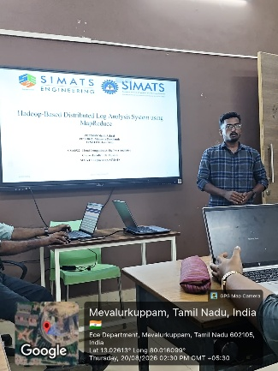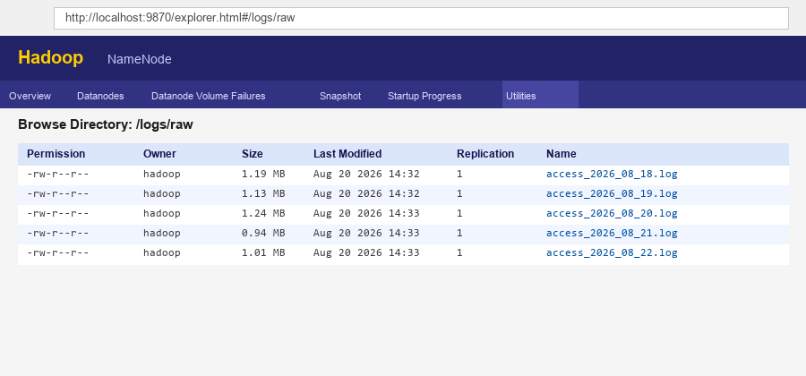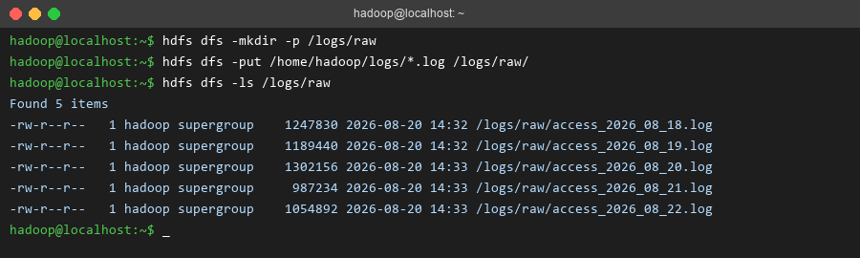

Project Description:
- Builds a distributed system to collect, store, and analyze large volumes of web server log data using the Hadoop ecosystem.
- Uses HDFS (Hadoop Distributed File System) to store raw log files reliably across a simulated multi-node cluster with data replication.
- Applies MapReduce (via Hadoop Streaming with Python) to parse log entries in parallel and extract key fields — IP address, request path, HTTP status code, and timestamp.
- Processes data in two phases: a Map phase that extracts facts from log lines across the cluster simultaneously, and a Reduce phase that aggregates them into final counts.
- Analyzes patterns such as most-requested pages, top traffic sources by IP, and frequency of error responses (4xx/5xx status codes).
- Loads the aggregated MapReduce output into a lightweight SQLite database for structured querying.
- Presents results through an interactive Streamlit and Plotly dashboard, visualizing traffic patterns and anomalies through charts and tables.
- Demonstrates that the same pipeline logic scales from a single test machine to a full multi-node cluster without any change to the underlying code.

Student Signature Guide Signature

